1. For the purposes of this question, I will define SAE = $\sum_{i=1}^{n}{}|y_{i}-w^{T}x_{i}|$

Given q3. The likelihood is then,

p(y|x, w) = $(\frac{n}{i=1}П)$ (p($y_{i}|x_{i}, w$)) =>

$(\frac{n}{i=1}П)$ ($\frac{1}{2b}e( \frac{-|y_{i}-w^{T}x_{i}|}{b})$) => $\frac{1}{(2b)^{n}}e^{\frac{-1}{b}}$ SAE

So then, as SAE is increasing, $\frac{-1}{b}$ SAE and $e^{\frac{-1}{b}}$ SAE is decreasing. So, SAE is proportional to likelihood when b is fixed. And so, likelihood is maxed when -SAE is maxed. Likewise, when it's minimized, MLE is also minimized.



| y | P(y|x) | t=0 | t=0.2 | t=0.4 | t=0.6 | t=0.8 | t=1 |
| --- | --- | --- | --- | --- | --- | --- | --- |
|  |  | 0.5 | 0.571 | 0.667 | 0.857 | 0.8 | 0 |
| 0 | 0.1 | 1 | 0 | 0 | 0 | 0 | 0 |
| 0 | 0.1 | 1 | 0 | 0 | 0 | 0 | 0 |
| 0 | 0.25 | 1 | 1 | 0 | 0 | 0 | 0 |
| 1 | 0.25 | 1 | 1 | 0 | 0 | 0 | 0 |
| 0 | 0.3 | 1 | 1 | 0 | 0 | 0 | 0 |
| 0 | 0.33 | 1 | 1 | 0 | 0 | 0 | 0 |
| 1 | 0.4 | 1 | 1 | 0 | 0 | 0 | 0 |
| 0 | 0.52 | 1 | 1 | 1 | 0 | 0 | 0 |
| 0 | 0.55 | 1 | 1 | 1 | 0 | 0 | 0 |
| 1 | 0.7 | 1 | 1 | 1 | 1 | 0 | 0 |
| 1 | 0.8 | 1 | 1 | 1 | 1 | 0 | 0 |
| 0 | 0.85 | 1 | 1 | 1 | 1 | 1 | 0 |
| 1 | 0.9 | 1 | 1 | 1 | 1 | 1 | 0 |
| 1 | 0.9 | 1 | 1 | 1 | 1 | 1 | 0 |
| 1 | 0.95 | 1 | 1 | 1 | 1 | 1 | 0 |
| 1 | 1.0 | 1 | 1 | 1 | 1 | 1 | 0 |

6. No Bias | Added Bias

1.0 = 74.68% | 96.57%

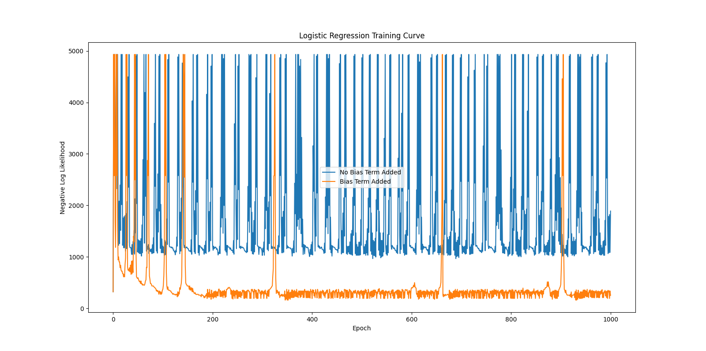

0.1 = 85.19% | 34.33%

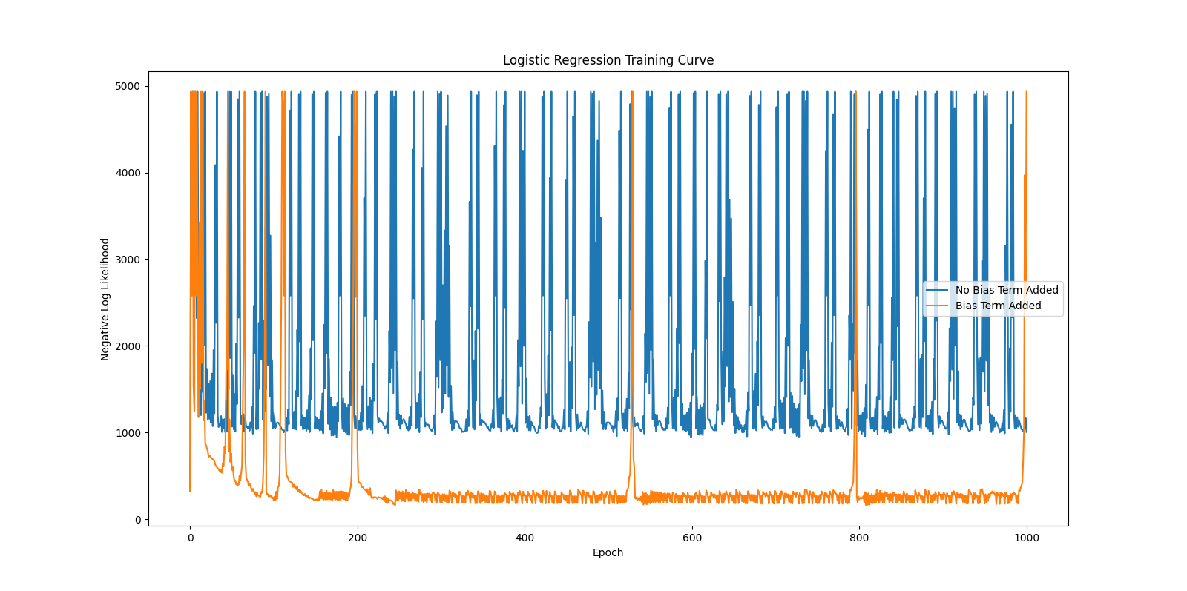

0.01 = 85.41% | 95.28%

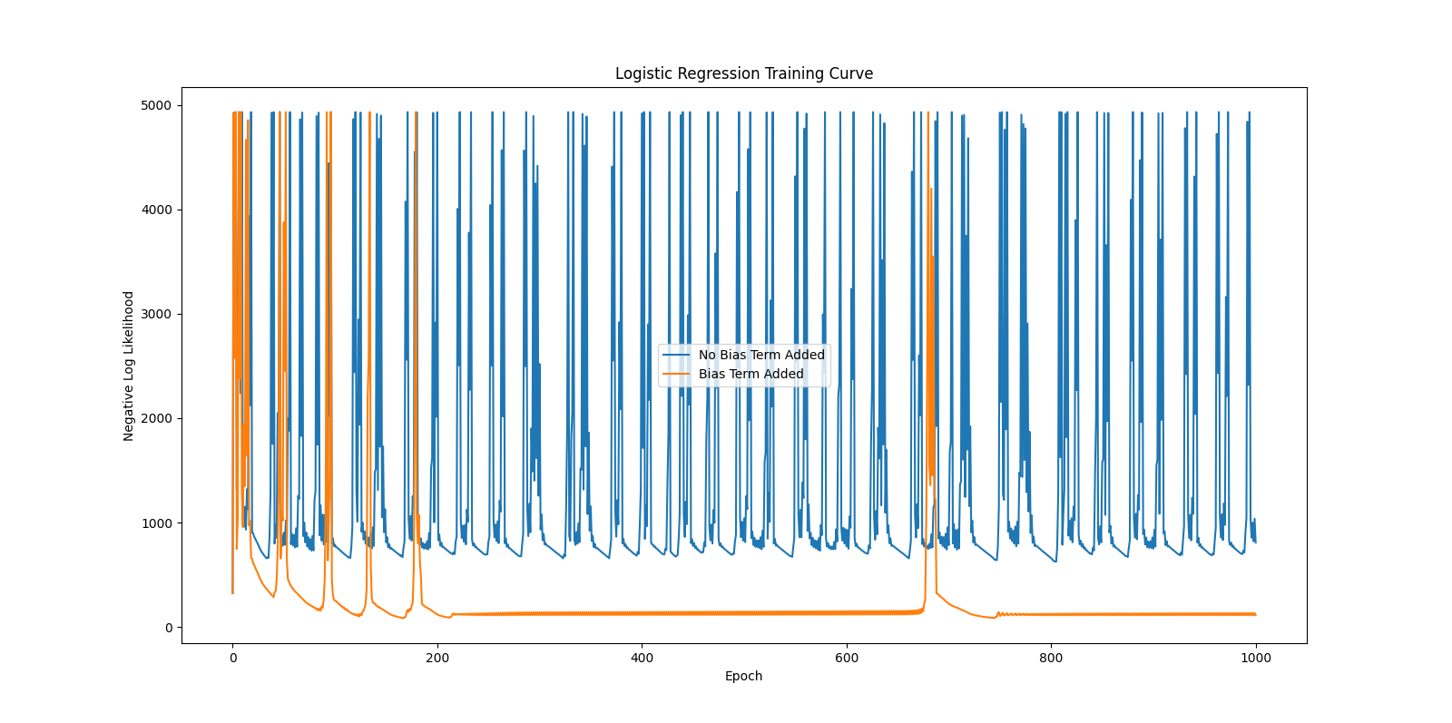

0.001 = 86.7% | 97.0%

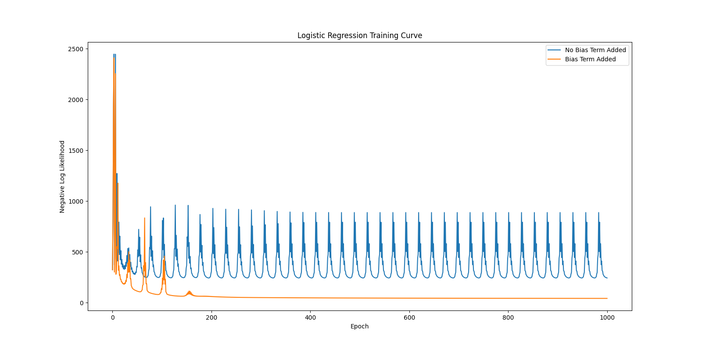

0.0001 = 86.2% | 96.35%

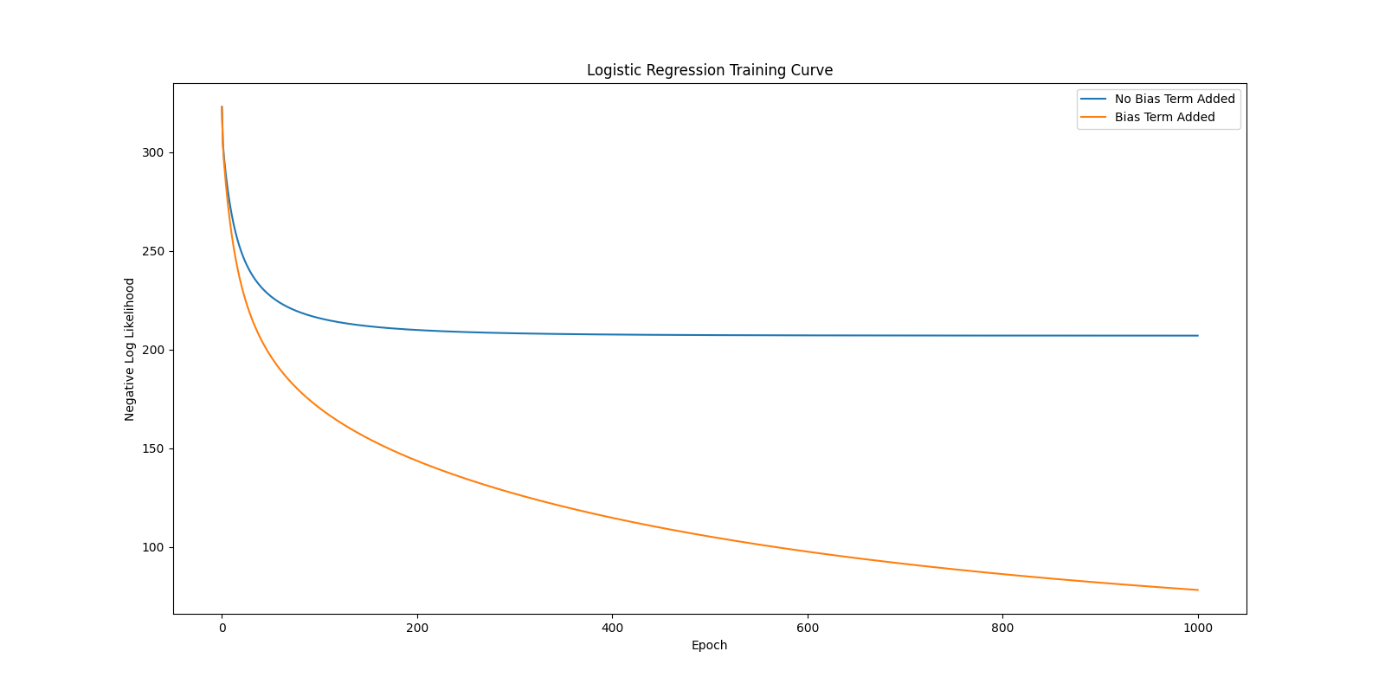

0.00001 = 85.62% | 90.77%

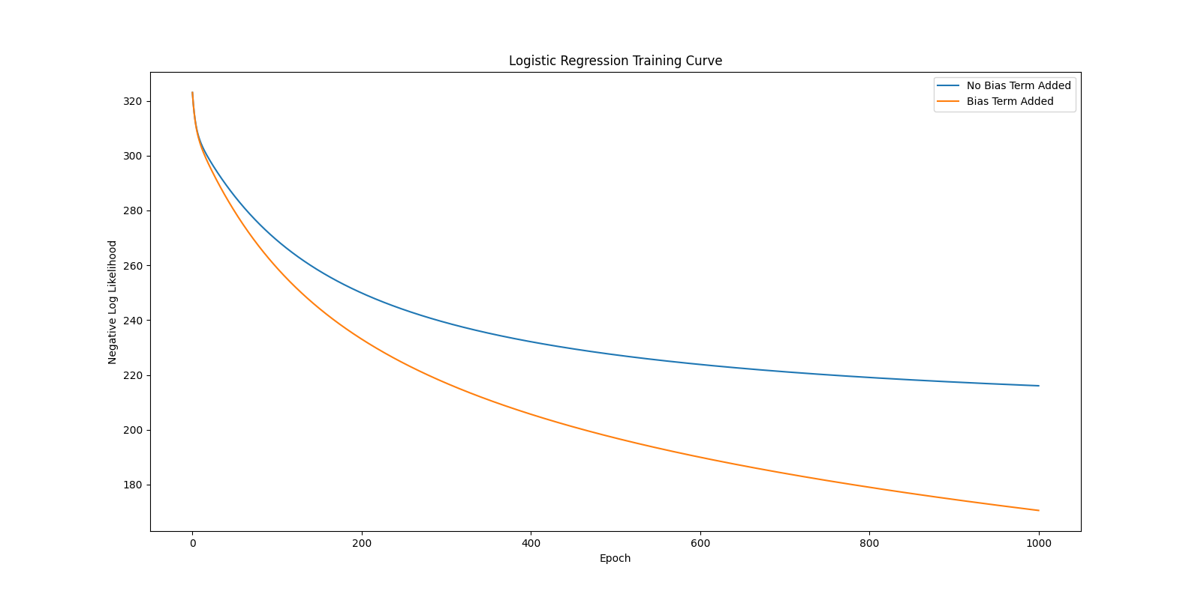

They start to converge and smooth out the smaller the steps become.

7. My leaderboard is terrible at 0.79310 with bias. My graph does dip low so I suppose it's accurate.

1. About 14 hours and I'm still not sure if it will get a decent grade.
2. If this was one of my only classes and I focused on this then it wouldn't be too bad but I'm very scattered with many other things happening that I can't give enough attention to this class. Also I'm not the best with math so that doesnt help in this class either.
3. Alone, with a few sanity checks from the professor.
4. 30% i got things working but i can't really reproduce it without walking through it again. This is not my focus of brain power.